Московский государственный технический
университет им. Н.Э. Баумана

Факультет информатика и системы управления
Кафедра системы обработки информации и управления

Курс «Парадигмы и конструкции языков программирования»

Домашнее задание
«Чат-бот на языке Go»

Выполнил: |  | Проверил:
студент группы ИУ5-32Б: |  | преподаватель каф. ИУ5
Пчелинцева Д.А. |  | Нардид А.Н.
Подпись и дата: 21.12.2025г. |  | Подпись и дата:

Москва, 2025 г.

Задание:
Задача этой работы — разработать Telegram-бота для помощи игрокам Genshin Impact в подборе оптимальных сборок персонажей. Бот должен:
- Находить сборку (артфакты, оружие, статы) по имени персонажа;
- Поддерживать поиск по русским и английским именам, а также по алиасам (например, «Аяка» → ayaka);
- Позволять сравнивать двух персонажей;
- Давать возможность добавлять персонажей в избранное (с сохранением между сессиями);
- Работать через удобное меню с кнопками.
Всё это реализовано на языке Go с использованием библиотеки go-telegram-bot-api.
Код программы:
Файл dz.go:
package main

import (
"encoding/json"
"fmt"
"log"
"os"
"regexp"
"strings"

tgbotapi "github.com/go-telegram-bot-api/telegram-bot-api/v5"
)

type Character struct {
NameEN string `json:"name_en"`
NameRU string `json:"name_ru"`
Role string `json:"role"`
Weapon string `json:"weapon"`
ArtifactSet interface{} `json:"artifact_set"`
Pieces interface{} `json:"pieces"`
Sands string `json:"sands"`
Goblet string `json:"goblet"`
Circlet string `json:"circlet"`
}

var (
botToken = "8374734234:AAFf66s_UYrJyfMxt_jgQwmuyXoWKxQhh4M"
characters map[string]Character
aliases map[string]string
userStates = make(map[string]string)
favorites = make(map[int64][]string)
)

const (
StateWaitingForCharacter = "waiting_for_character"
StateWaitingForCompare1 = "waiting_for_compare_1"
StateWaitingForCompare2 = "waiting_for_compare_2"
)

// === Нормализация: убираем всё, кроме букв и цифр ===
func normalize(s string) string {
reg := regexp.MustCompile(`[^a-zA-Zа-яА-Я0-9]`)
return strings.ToLower(reg.ReplaceAllString(s, ""))
}

func main() {
bot, err := tgbotapi.NewBotAPI(botToken)
if err != nil {
log.Fatal("❌ Не удалось создать бота:", err)
}
bot.Debug = false
log.Printf("✅ Бот запущен как @%s", bot.Self.UserName)

loadConfig()

u := tgbotapi.NewUpdate(0)
u.Timeout = 60
updates := bot.GetUpdatesChan(u)

for update := range updates {
if update.Message != nil {
handleMessage(bot, update.Message)
}
}
}

func loadConfig() {
data, err := os.ReadFile("config.json")
if err != nil {
log.Fatal("❌ Не найден config.json")
}

var cfg struct {
Characters map[string]Character `json:"characters"`
Aliases map[string]string `json:"aliases"`
}
if err := json.Unmarshal(data, &cfg); err != nil {
log.Fatal("❌ Ошибка парсинга config.json:", err)
}

characters = cfg.Characters
aliases = cfg.Aliases
log.Printf("✅ Загружено персонажей: %d", len(characters))
}

// === НАДЕЖНЫЙ ПОИСК ПЕРСОНАЖА ===
func findCharacter(query string) (key string, c *Character) {
q := normalize(query)

// По ключу
if c, ok := characters[q]; ok {
return q, &c
}

// По алиасу
if realKey, ok := aliases[q]; ok {
if c, ok := characters[realKey]; ok {
return realKey, &c
}
}

// По имени
for k, char := range characters {
if normalize(char.NameEN) == q || normalize(char.NameRU) == q {
return k, &char
}
}

return "", nil
}

func handleMessage(bot *tgbotapi.BotAPI, msg *tgbotapi.Message) {
chatID := msg.Chat.ID
text := strings.TrimSpace(msg.Text)
chatIDStr := fmt.Sprint(chatID)

if text == "/start" || text == "/hello" {
start(bot, msg)
return
}
if text == "/fav" {
showFavorites(bot, msg)
return
}
if strings.HasPrefix(text, "/compare ") {
compareCommand(bot, msg, text[9:])
return
}
if strings.HasPrefix(text, "⭐") {
name := strings.TrimSpace(strings.TrimPrefix(text, "⭐"))
if name != "" {
addToFavorites(bot, msg, name)
return
}
}

// Состояние: ожидание второго персонажа
if userStates[chatIDStr] == StateWaitingForCompare2 {
if text == "🔙 Вернуться в меню" {
delete(userStates, chatIDStr)
delete(userStates, chatIDStr+"_char1")
sendMessageWithKeyboard(bot, chatID, "Возврат в меню", menuKeyboard())
return
}
first := userStates[chatIDStr+"_char1"]
_, c1 := findCharacter(first)
_, c2 := findCharacter(text)
if c1 != nil && c2 != nil {
doCompare(bot, msg, *c1, *c2)
} else {
bot.Send(tgbotapi.NewMessage(chatID, "❌ Один из персонажей не найден."))
}
delete(userStates, chatIDStr)
delete(userStates, chatIDStr+"_char1")
sendMessageWithKeyboard(bot, chatID, "Возврат в меню", menuKeyboard())
return
}

// Состояние: ожидание первого персонажа для сравнения
if userStates[chatIDStr] == StateWaitingForCompare1 {
if text == "🔙 Вернуться в меню" {
delete(userStates, chatIDStr)
sendMessageWithKeyboard(bot, chatID, "Возврат в меню", menuKeyboard())
return
}
_, c := findCharacter(text)
if c == nil {
bot.Send(tgbotapi.NewMessage(chatID, "❌ Персонаж не найден. Попробуйте ещё раз."))
return
}
userStates[chatIDStr] = StateWaitingForCompare2
userStates[chatIDStr+"_char1"] = text
msgConf := tgbotapi.NewMessage(chatID, fmt.Sprintf("✅ Выбран: *%s*\nВведите имя второго персонажа:", c.NameRU))
msgConf.ParseMode = "Markdown"
msgConf.ReplyMarkup = backKeyboard()
bot.Send(msgConf)
return
}

// Состояние: ожидание персонажа для сборки
if userStates[chatIDStr] == StateWaitingForCharacter {
if text == "🔙 Вернуться в меню" {
delete(userStates, chatIDStr)
sendMessageWithKeyboard(bot, chatID, "Возврат в меню", menuKeyboard())
return
}
showBuild(bot, msg, text)
return
}

// Главное меню
switch text {
case "⚡ О боте ⚡":
about(bot, msg)
case "🌟 Избранное":
showFavorites(bot, msg)
case "Артефакты персонажей":
userStates[chatIDStr] = StateWaitingForCharacter
msgConf := tgbotapi.NewMessage(chatID, "Введите имя персонажа (например: *Аяка*, *Ху Тао*, *Сяо*):")
msgConf.ParseMode = "Markdown"
msgConf.ReplyMarkup = backKeyboard()
bot.Send(msgConf)
case "🆚 Сравнить персонажей":
userStates[chatIDStr] = StateWaitingForCompare1
msgConf := tgbotapi.NewMessage(chatID, "Введите имя первого персонажа:")
msgConf.ParseMode = "Markdown"
msgConf.ReplyMarkup = backKeyboard()
bot.Send(msgConf)
case "↩️ Выход ↩️":
msgConf := tgbotapi.NewMessage(chatID, "До новых встреч! 👋")
msgConf.ReplyMarkup = tgbotapi.NewRemoveKeyboard(true)
bot.Send(msgConf)
case "🔙 Вернуться в меню":
delete(userStates, chatIDStr)
delete(userStates, chatIDStr+"_char1")
sendMessageWithKeyboard(bot, chatID, "Возврат в меню", menuKeyboard())
default:
sendMessageWithKeyboard(bot, chatID, "Пожалуйста, используйте кнопки меню.", menuKeyboard())
}
}

func sendMessageWithKeyboard(bot *tgbotapi.BotAPI, chatID int64, text string, keyboard interface{}) {
msg := tgbotapi.NewMessage(chatID, text)
msg.ReplyMarkup = keyboard
bot.Send(msg)
}

func menuKeyboard() tgbotapi.ReplyKeyboardMarkup {
return tgbotapi.NewReplyKeyboard(
tgbotapi.NewKeyboardButtonRow(
tgbotapi.NewKeyboardButton("⚡ О боте ⚡"),
tgbotapi.NewKeyboardButton("🌟 Избранное"),
),
tgbotapi.NewKeyboardButtonRow(
tgbotapi.NewKeyboardButton("Артефакты персонажей"),
tgbotapi.NewKeyboardButton("🆚 Сравнить персонажей"),
),
tgbotapi.NewKeyboardButtonRow(
tgbotapi.NewKeyboardButton("↩️ Выход ↩️"),
),
)
}

func backKeyboard() tgbotapi.ReplyKeyboardMarkup {
return tgbotapi.NewReplyKeyboard(
tgbotapi.NewKeyboardButtonRow(tgbotapi.NewKeyboardButton("🔙 Вернуться в меню")),
)
}

func start(bot *tgbotapi.BotAPI, msg *tgbotapi.Message) {
text := fmt.Sprintf(
"Привет, %s! 👋\n"+
"Я помогу собрать персонажей в Genshin Impact.\n"+
"• Нажмите Артефакты персонажей, чтобы найти сборку.\n"+
"• Сохраняйте любимых в Избранное (⭐ Имя).\n"+
"• Используйте Сравнить, чтобы выбрать лучшего.",
msg.From.FirstName,
)
sendMessageWithKeyboard(bot, msg.Chat.ID, text, menuKeyboard())
}

func about(bot *tgbotapi.BotAPI, msg *tgbotapi.Message) {
sendMessageWithKeyboard(bot, msg.Chat.ID,
"🤖 Бот создан для помощи в сборке персонажей Genshin Impact.\n\n"+
"Данные взяты с https://genshin.gg/builds/",
menuKeyboard())
}

func showBuild(bot *tgbotapi.BotAPI, msg *tgbotapi.Message, query string) {
_, c := findCharacter(query)
if c == nil {
bot.Send(tgbotapi.NewMessage(msg.Chat.ID, "❌ Персонаж не найден. Попробуйте: *Аяка*, *Ху Тао*, *Сяо*, *Путешественник (Анемо)* и т.д."))
return
}

var artifactLine string
switch v := c.ArtifactSet.(type) {
case string:
artifactLine = v
case []interface{}:
parts := make([]string, len(v))
for i, p := range v {
if s, ok := p.(string); ok {
parts[i] = s
} else {
parts[i] = fmt.Sprintf("%v", p)
}
}
artifactLine = strings.Join(parts, " + ")
default:
artifactLine = "неизвестно"
}

var piecesLine string
switch v := c.Pieces.(type) {
case float64:
piecesLine = fmt.Sprintf("%.0f шт.", v)
case []interface{}:
if len(v) >= 2 {
p1 := v[0].(float64)
p2 := v[1].(float64)
piecesLine = fmt.Sprintf("%.0f + %.0f шт.", p1, p2)
} else {
piecesLine = "данные отсутствуют"
}
default:
piecesLine = "данные отсутствуют"
}

reply := fmt.Sprintf(
"✨ *%s* (%s) — _%s_\n\n"+
"⚔️ *Оружие*: %s\n"+
"🛡️ *Сет*: %s (%s)\n\n"+
"🔮 *Статы*:\n"+
"• Пески: %s\n"+
"• Кубок: %s\n"+
"• Тиара: %s",
c.NameEN, c.NameRU, c.Role,
c.Weapon, artifactLine, piecesLine,
c.Sands, c.Goblet, c.Circlet,
)

msgConf := tgbotapi.NewMessage(msg.Chat.ID, reply)
msgConf.ParseMode = "Markdown"
msgConf.ReplyMarkup = backKeyboard()
bot.Send(msgConf)
}

func addToFavorites(bot *tgbotapi.BotAPI, msg *tgbotapi.Message, query string) {
chatID := msg.Chat.ID
key, c := findCharacter(query)
if c == nil {
bot.Send(tgbotapi.NewMessage(chatID, "❌ Персонаж не найден. Проверьте написание."))
return
}
for _, k := range favorites[chatID] {
if k == key {
bot.Send(tgbotapi.NewMessage(chatID, fmt.Sprintf("✨ %s уже в избранном!", c.NameRU)))
return
}
}
favorites[chatID] = append(favorites[chatID], key)
bot.Send(tgbotapi.NewMessage(chatID, fmt.Sprintf("✅ %s добавлен(а) в избранное!", c.NameRU)))
}

func showFavorites(bot *tgbotapi.BotAPI, msg *tgbotapi.Message) {
chatID := msg.Chat.ID
list := favorites[chatID]
if len(list) == 0 {
bot.Send(tgbotapi.NewMessage(chatID, "Ваше избранное пусто. Добавьте персонажа: ⭐ Имя"))
return
}
var lines []string
for _, key := range list {
if c, ok := characters[key]; ok {
lines = append(lines, fmt.Sprintf("• %s (%s)", c.NameRU, c.Role))
}
}
bot.Send(tgbotapi.NewMessage(chatID, "🌟 Ваше избранное:\n"+strings.Join(lines, "\n")))
}

func compareCommand(bot *tgbotapi.BotAPI, msg *tgbotapi.Message, args string) {
parts := strings.Split(strings.ToLower(args), " и ")
if len(parts) != 2 {
bot.Send(tgbotapi.NewMessage(msg.Chat.ID,
"❗ Формат: /compare Имя1 и Имя2\nПример: /compare Аяка и Ху Тао"))
return
}
_, c1 := findCharacter(parts[0])
_, c2 := findCharacter(parts[1])
if c1 == nil || c2 == nil {
bot.Send(tgbotapi.NewMessage(msg.Chat.ID, "❌ Один из персонажей не найден."))
return
}
doCompare(bot, msg, *c1, *c2)
}

func doCompare(bot *tgbotapi.BotAPI, msg *tgbotapi.Message, c1, c2 Character) {
format := func(c Character) string {
artifact := ""
switch v := c.ArtifactSet.(type) {
case string:
artifact = v
case []interface{}:
parts := make([]string, len(v))
for i, p := range v {
if s, ok := p.(string); ok {
parts[i] = s
} else {
parts[i] = fmt.Sprintf("%v", p)
}
}
artifact = strings.Join(parts, " + ")
default:
artifact = "неизвестно"
}
return fmt.Sprintf("%s (%s)\nОружие: %s\nСет: %s", c.NameRU, c.Role, c.Weapon, artifact)
}
reply := "🆚 Сравнение:\n\n🔵 " + format(c1) + "\n\n🔴 " + format(c2)
bot.Send(tgbotapi.NewMessage(msg.Chat.ID, reply))
}

Файл config.json:
{
"characters": {
"albedo": {
"name_en": "Albedo",
"name_ru": "Альбедо",
"role": "Sub DPS",
"weapon": "Peak Patrol Song",
"artifact_set": "Husk of Opulent Dreams",
"pieces": 4,
"sands": "DEF%",
"goblet": "Geo DMG",
"circlet": "CRIT Rate / DMG / DEF%"
},
"alhaitham": {
"name_en": "Alhaitham",
"name_ru": "Алхайтам",
"role": "Main DPS",
"weapon": "Light of Foliar Incision",
"artifact_set": "Gilded Dreams",
"pieces": 4,
"sands": "EM / ATK%",
"goblet": "Dendro DMG",
"circlet": "CRIT Rate / DMG"
},
"arlecchino": {
"name_en": "Arlecchino",
"name_ru": "Арлекино",
"role": "Main DPS",
"weapon": "Crimson Moon's Semblance",
"artifact_set": "Fragment of Harmonic Whimsy",
"pieces": 4,
"sands": "ATK%",
"goblet": "Pyro DMG",
"circlet": "CRIT Rate / DMG"
},
"ayaka": {
"name_en": "Ayaka",
"name_ru": "Аяка",
"role": "Main DPS",
"weapon": "Mistsplitter Reforged",
"artifact_set": "Blizzard Strayer",
"pieces": 4,
"sands": "ATK%",
"goblet": "Cryo DMG",
"circlet": "CRIT DMG / ATK%"
},
"chasca": {
"name_en": "Chasca",
"name_ru": "Часка",
"role": "Main DPS",
"weapon": "Astral Vulture's Crimson Plumage",
"artifact_set": "Obsidian Codex",
"pieces": 4,
"sands": "ATK%",
"goblet": "ATK%",
"circlet": "CRIT Rate / DMG"
},
"chiori": {
"name_en": "Chiori",
"name_ru": "Чиори",
"role": "Sub DPS",
"weapon": "Uraku Misugiri",
"artifact_set": "Golden Troupe",
"pieces": 4,
"sands": "DEF%",
"goblet": "Geo DMG / DEF%",
"circlet": "CRIT Rate / DMG / DEF%"
},
"citlali": {
"name_en": "Citlali",
"name_ru": "Ситлали",
"role": "Support",
"weapon": "Starcaller's Watch",
"artifact_set": "Scroll of the Hero of Cinder City",
"pieces": 4,
"sands": "EM / ER",
"goblet": "EM",
"circlet": "EM"
},
"clorinde": {
"name_en": "Clorinde",
"name_ru": "Клоринде",
"role": "Main DPS",
"weapon": "Absolution",
"artifact_set": "Fragment of Harmonic Whimsy",
"pieces": 4,
"sands": "ATK%",
"goblet": "Electro DMG",
"circlet": "CRIT Rate / DMG"
},
"cyno": {
"name_en": "Cyno",
"name_ru": "Сино",
"role": "Main DPS",
"weapon": "Staff of the Scarlet Sands",
"artifact_set": "Thundering Fury",
"pieces": 4,
"sands": "EM",
"goblet": "Electro DMG",
"circlet": "CRIT Rate / DMG"
},
"diluc": {
"name_en": "Diluc",
"name_ru": "Дилюк",
"role": "Main DPS",
"weapon": "Redhorn Stonethresher",
"artifact_set": "Crimson Witch of Flames",
"pieces": 4,
"sands": "ATK% / EM",
"goblet": "Pyro DMG",
"circlet": "CRIT Rate / DMG"
},
"emilie": {
"name_en": "Emilie",
"name_ru": "Эмили",
"role": "Sub DPS",
"weapon": "Lumidouce Elegy",
"artifact_set": "Unfinished Reverie",
"pieces": 4,
"sands": "ATK%",
"goblet": "Dendro DMG",
"circlet": "CRIT Rate / DMG"
},
"escoffier": {
"name_en": "Escoffier",
"name_ru": "Эскوفيye",
"role": "Sub DPS",
"weapon": "Symphonist of Scents",
"artifact_set": "Golden Troupe",
"pieces": 4,
"sands": "ATK% / ER",
"goblet": "Cryo DMG",
"circlet": "CRIT Rate / DMG"
},
"flins": {
"name_en": "Flins",
"name_ru": "Флинс",
"role": "Main DPS",
"weapon": "Bloodsoaked Ruins",
"artifact_set": "Night of the Sky's Unveiling",
"pieces": 4,
"sands": "ATK%",
"goblet": "ATK%",
"circlet": "CRIT Rate / DMG"
},
"furina": {
"name_en": "Furina",
"name_ru": "Фурина",
"role": "Sub DPS",
"weapon": "Splendor of Tranquil Waters",
"artifact_set": "Golden Troupe",
"pieces": 4,
"sands": "ER",
"goblet": "Hydro DMG",
"circlet": "CRIT Rate / DMG"
},
"hu_tao": {
"name_en": "Hu Tao",
"name_ru": "Ху Тао",
"role": "Main DPS",
"weapon": "Staff of Homa",
"artifact_set": "Crimson Witch of Flames",
"pieces": 4,
"sands": "HP% / EM",
"goblet": "Pyro DMG",
"circlet": "CRIT Rate / DMG"
},
"itto": {
"name_en": "Itto",
"name_ru": "Итто",
"role": "Main DPS",
"weapon": "Redhorn Stonethresher",
"artifact_set": "Husk of Opulent Dreams",
"pieces": 4,
"sands": "DEF%",
"goblet": "Geo DMG",
"circlet": "CRIT Rate / DMG"
},
"jean": {
"name_en": "Jean",
"name_ru": "Жан",
"role": "Support",
"weapon": "Primordial Jade Cutter",
"artifact_set": "Viridescent Venerer",
"pieces": 4,
"sands": "ATK% / ER",
"goblet": "Anemo DMG",
"circlet": "CRIT Rate / DMG"
},
"keqing": {
"name_en": "Keqing",
"name_ru": "Ке Цин",
"role": "Main DPS",
"weapon": "Mistsplitter Reforged",
"artifact_set": "Thundering Fury",
"pieces": 4,
"sands": "ATK%",
"goblet": "Electro DMG",
"circlet": "CRIT Rate / DMG"
},
"kinich": {
"name_en": "Kinich",
"name_ru": "Кинич",
"role": "Main DPS",
"weapon": "Fang of the Mountain King",
"artifact_set": "Obsidian Codex",
"pieces": 4,
"sands": "ATK%",
"goblet": "Dendro DMG",
"circlet": "CRIT DMG"
},
"klee": {
"name_en": "Klee",
"name_ru": "Кли",
"role": "Main DPS",
"weapon": "The Widsith",
"artifact_set": ["Crimson Witch of Flames", "Shimenawa's Reminiscence"],
"pieces": [2, 2],
"sands": "ATK%",
"goblet": "Pyro DMG",
"circlet": "CRIT Rate / DMG"
},
"kokomi": {
"name_en": "Kokomi",
"name_ru": "Кокоми",
"role": "Support",
"weapon": "Thrilling Tales of Dragon Slayers",
"artifact_set": "Tenacity of the Millelith",
"pieces": 4,
"sands": "HP% / ER",
"goblet": "HP%",
"circlet": "HP% / Healing"
},
"lyney": {
"name_en": "Lyney",
"name_ru": "Лини",
"role": "Main DPS",
"weapon": "The First Great Magic",
"artifact_set": "Marechaussee Hunter",
"pieces": 4,
"sands": "ATK%",
"goblet": "Pyro DMG",
"circlet": "CRIT Rate / DMG"
},
"mavuika": {
"name_en": "Mavuika",
"name_ru": "Мавуика",
"role": "Main DPS",
"weapon": "A Thousand Blazing Suns",
"artifact_set": "Obsidian Codex",
"pieces": 4,
"sands": "EM",
"goblet": "Pyro DMG",
"circlet": "CRIT Rate / DMG"
},
"mona": {
"name_en": "Mona",
"name_ru": "Мона",
"role": "Support",
"weapon": "Thrilling Tales of Dragon Slayers",
"artifact_set": "Noblesse Oblige",
"pieces": 4,
"sands": "ER / ATK%",
"goblet": "Hydro DMG / ATK%",
"circlet": "CRIT Rate"
},
"navia": {
"name_en": "Navia",
"name_ru": "Навия",
"role": "Main DPS",
"weapon": "Verdict",
"artifact_set": "Nighttime Whispers in the Echoing Woods",
"pieces": 4,
"sands": "ATK%",
"goblet": "Geo DMG",
"circlet": "CRIT Rate / DMG"
},
"nefer": {
"name_en": "Nefer",
"name_ru": "Нефер",
"role": "Main DPS",
"weapon": "Reliquary of Truth",
"artifact_set": "Night of the Sky's Unveiling",
"pieces": 4,
"sands": "EM",
"goblet": "EM",
"circlet": "CRIT Rate / DMG"
},
"neuvillette": {
"name_en": "Neuvillette",
"name_ru": "Нёвиллет",
"role": "Main DPS",
"weapon": "Tome of the Eternal Flow",
"artifact_set": "Marechaussee Hunter",
"pieces": 4,
"sands": "HP%",
"goblet": "Hydro DMG",
"circlet": "CRIT Rate / DMG"
},
"nilou": {
"name_en": "Nilou",
"name_ru": "Нилу",
"role": "Support",
"weapon": "Key of Khaj-Nisut",
"artifact_set": ["Heart of Depth", "Tenacity of the Millelith"],
"pieces": [2, 2],
"sands": "HP% / ER",
"goblet": "HP%",
"circlet": "HP%"
},
"qiqi": {
"name_en": "Qiqi",
"name_ru": "Ци Ци",
"role": "Support",
"weapon": "Sacrificial Sword",
"artifact_set": "Tenacity of the Millelith",
"pieces": 4,
"sands": "ATK% / ER",
"goblet": "ATK%",
"circlet": "ATK% / Healing"
},
"raiden": {
"name_en": "Raiden Shogun",
"name_ru": "Райден Шогун",
"role": "Sub DPS",
"weapon": "Engulfing Lightning",
"artifact_set": "Emblem of Severed Fate",
"pieces": 4,
"sands": "ER / ATK%",
"goblet": "Electro DMG / ATK%",
"circlet": "CRIT Rate / DMG"
},
"skirk": {
"name_en": "Skirk",
"name_ru": "Скирк",
"role": "Main DPS",
"weapon": "Azurelight",
"artifact_set": "Finale of the Deep Galleries",
"pieces": 4,
"sands": "ATK%",
"goblet": "Cryo DMG / ATK%",
"circlet": "CRIT Rate / DMG"
},
"tighnari": {
"name_en": "Tighnari",
"name_ru": "Тигнари",
"role": "Sub DPS",
"weapon": "Hunter's Path",
"artifact_set": "Wanderer's Troupe",
"pieces": 4,
"sands": "ATK% / EM",
"goblet": "Dendro DMG",
"circlet": "CRIT Rate / DMG"
},
"traveler_anemo": {
"name_en": "Traveler (Anemo)",
"name_ru": "Путешественник (Анемо)",
"role": "Sub DPS",
"weapon": "Freedom-Sworn",
"artifact_set": "Viridescent Venerer",
"pieces": 4,
"sands": "EM / ATK% / ER",
"goblet": "EM / Anemo DMG",
"circlet": "EM / CRIT Rate / DMG"
},
"traveler_dendro": {
"name_en": "Traveler (Dendro)",
"name_ru": "Путешественник (Дендро)",
"role": "Support",
"weapon": "Freedom-Sworn",
"artifact_set": "Deepwood Memories",
"pieces": 4,
"sands": "ER / ATK%",
"goblet": "Dendro DMG",
"circlet": "CRIT Rate / DMG"
},
"traveler_electro": {
"name_en": "Traveler (Electro)",
"name_ru": "Путешественник (Электро)",
"role": "Support",
"weapon": "Favonius Sword",
"artifact_set": "Noblesse Oblige",
"pieces": 4,
"sands": "ER",
"goblet": "Electro DMG",
"circlet": "CRIT Rate / DMG"
},
"traveler_geo": {
"name_en": "Traveler (Geo)",
"name_ru": "Путешественник (Гео)",
"role": "Sub DPS",
"weapon": "Primordial Jade Cutter",
"artifact_set": ["Archaic Petra", "Noblesse Oblige"],
"pieces": [2, 2],
"sands": "ATK%",
"goblet": "Geo DMG",
"circlet": "CRIT Rate / DMG"
},
"traveler_pyro": {
"name_en": "Traveler (Pyro)",
"name_ru": "Путешественник (Пиро)",
"role": "Support",
"weapon": "Favonius Sword",
"artifact_set": "Scroll of the Hero of Cinder City",
"pieces": 4,
"sands": "ER",
"goblet": "Pyro DMG",
"circlet": "CRIT Rate / DMG"
},
"wanderer": {
"name_en": "Wanderer",
"name_ru": "Странник",
"role": "Main DPS",
"weapon": "Tulaytullah's Remembrance",
"artifact_set": "Desert Pavilion Chronicle",
"pieces": 4,
"sands": "ATK%",
"goblet": "Anemo DMG",
"circlet": "CRIT Rate / DMG"
},
"wriothesley": {
"name_en": "Wriothesley",
"name_ru": "Вриотесли",
"role": "Main DPS",
"weapon": "Cashflow Supervision",
"artifact_set": "Marechaussee Hunter",
"pieces": 4,
"sands": "ATK%",
"goblet": "Cryo DMG",
"circlet": "CRIT Rate / DMG"
},
"xianyun": {
"name_en": "Xianyun",
"name_ru": "Сяньюнь",
"role": "Support",
"weapon": "Crane's Echoing Call",
"artifact_set": "Viridescent Venerer",
"pieces": 4,
"sands": "ER / ATK%",
"goblet": "ATK%",
"circlet": "Healing / ATK%"
},
"xiao": {
"name_en": "Xiao",
"name_ru": "Сяо",
"role": "Main DPS",
"weapon": "Primordial Jade Winged-Spear",
"artifact_set": "Vermillion Hereafter",
"pieces": 4,
"sands": "ATK%",
"goblet": "Anemo DMG",
"circlet": "CRIT Rate / DMG"
},
"xilonen": {
"name_en": "Xilonen",
"name_ru": "Ксилонен",
"role": "Support",
"weapon": "Peak Patrol Song",
"artifact_set": "Scroll of the Hero of Cinder City",
"pieces": 4,
"sands": "DEF% / ER",
"goblet": "DEF%",
"circlet": "DEF% / Healing"
},
"yae_miko": {
"name_en": "Yae Miko",
"name_ru": "Яэ Мико",
"role": "Sub DPS",
"weapon": "Kagura's Verity",
"artifact_set": "Emblem of Severed Fate",
"pieces": 4,
"sands": "ER / ATK%",
"goblet": "Electro DMG",
"circlet": "CRIT Rate / DMG"
},
"yelan": {
"name_en": "Yelan",
"name_ru": "Илань",
"role": "Sub DPS",
"weapon": "Elegy for the End",
"artifact_set": "Emblem of Severed Fate",
"pieces": 4,
"sands": "ER",
"goblet": "Hydro DMG",
"circlet": "CRIT Rate / DMG"
},
"yoimiya": {
"name_en": "Yoimiya",
"name_ru": "Йоимия",
"role": "Main DPS",
"weapon": "Thundering Pulse",
"artifact_set": "Shimenawa's Reminiscence",
"pieces": 4,
"sands": "ATK% / EM",
"goblet": "Pyro DMG",
"circlet": "CRIT Rate / DMG"
},
"yumemizuki_mizuki": {
"name_en": "Yumemizuki Mizuki",
"name_ru": "Юмэмидзуки Мидзуки",
"role": "Main DPS",
"weapon": "Sunny Morning Sleep-In",
"artifact_set": "Viridescent Venerer",
"pieces": 4,
"sands": "EM / ER",
"goblet": "EM",
"circlet": "EM"
},
"beidou": {
"name_en": "Beidou",
"name_ru": "Бэйдоу",
"role": "Sub DPS",
"weapon": "Wolf's Gravestone",
"artifact_set": "Emblem of Severed Fate",
"pieces": 4,
"sands": "ATK% / ER",
"goblet": "Electro DMG",
"circlet": "CRIT Rate / DMG"
},
"bennett": {
"name_en": "Bennett",
"name_ru": "Беннет",
"role": "Support",
"weapon": "Mistsplitter Reforged",
"artifact_set": "Noblesse Oblige",
"pieces": 4,
"sands": "ATK% / ER",
"goblet": "Pyro DMG",
"circlet": "CRIT Rate / DMG"
},
"chongyun": {
"name_en": "Chongyun",
"name_ru": "Чуньюнь",
"role": "Support",
"weapon": "Wolf's Gravestone",
"artifact_set": ["Blizzard Strayer", "Noblesse Oblige"],
"pieces": [2, 2],
"sands": "ATK% / ER / EM",
"goblet": "Cryo DMG",
"circlet": "CRIT Rate / DMG"
},
"collei": {
"name_en": "Collei",
"name_ru": "Колли",
"role": "Support",
"weapon": "Elegy for the End",
"artifact_set": "Deepwood Memories",
"pieces": 4,
"sands": "ER / ATK% / EM",
"goblet": "Dendro DMG",
"circlet": "CRIT Rate / DMG"
},
"dori": {
"name_en": "Dori",
"name_ru": "Дори",
"role": "Support",
"weapon": "Favonius Greatsword",
"artifact_set": "Noblesse Oblige",
"pieces": 4,
"sands": "ER / HP% / EM",
"goblet": "HP% / EM",
"circlet": "Healing / HP% / EM"
},
"fischl": {
"name_en": "Fischl",
"name_ru": "Фишль",
"role": "Sub DPS",
"weapon": "Aqua Simulacra",
"artifact_set": "Golden Troupe",
"pieces": 4,
"sands": "ATK% / EM",
"goblet": "Electro DMG",
"circlet": "CRIT Rate / DMG"
},
"gaming": {
"name_en": "Gaming",
"name_ru": "Гейминг",
"role": "Main DPS",
"weapon": "Serpent Spine",
"artifact_set": "Crimson Witch of Flames",
"pieces": 4,
"sands": "EM",
"goblet": "Pyro DMG",
"circlet": "CRIT Rate / DMG"
},
"ifa": {
"name_en": "Ifa",
"name_ru": "Ифа",
"role": "Sub DPS",
"weapon": "Tulaytullah's Remembrance",
"artifact_set": "Obsidian Codex",
"pieces": 4,
"sands": "ATK%",
"goblet": "Anemo DMG",
"circlet": "CRIT Rate / DMG"
},
"kachina": {
"name_en": "Kachina",
"name_ru": "Качина",
"role": "Sub DPS",
"weapon": "Favonius Lance",
"artifact_set": "Scroll of the Hero of Cinder City",
"pieces": 4,
"sands": "ER / DEF%",
"goblet": "Geo DMG / DEF%",
"circlet": "CRIT Rate / DMG"
},
"kaeya": {
"name_en": "Kaeya",
"name_ru": "Каэя",
"role": "Sub DPS",
"weapon": "Primordial Jade Cutter",
"artifact_set": "Emblem of Severed Fate",
"pieces": 4,
"sands": "ER / ATK%",
"goblet": "Cryo DMG",
"circlet": "CRIT Rate / DMG"
},
"kirara": {
"name_en": "Kirara",
"name_ru": "Кирака",
"role": "Support",
"weapon": "Favonius Sword",
"artifact_set": ["Tenacity of the Millelith", "Vourukasha's Glow"],
"pieces": [2, 2],
"sands": "HP% / ER",
"goblet": "HP%",
"circlet": "HP%"
},
"lisa": {
"name_en": "Lisa",
"name_ru": "Лиза",
"role": "Support",
"weapon": "Kagura's Verity",
"artifact_set": "Emblem of Severed Fate",
"pieces": 4,
"sands": "Elemental Master / ATK%",
"goblet": "Electro DMG",
"circlet": "CRIT Rate / DMG"
},
"lynette": {
"name_en": "Lynette",
"name_ru": "Линетт",
"role": "Support",
"weapon": "Sacrificial Sword",
"artifact_set": "Viridescent Venerer",
"pieces": 4,
"sands": "ER / ATK%",
"goblet": "Anemo DMG",
"circlet": "CRIT Rate / DMG"
},
"ningguang": {
"name_en": "Ningguang",
"name_ru": "Нин Гуан",
"role": "Main DPS",
"weapon": "Lost Prayer to the Sacred Winds",
"artifact_set": ["Archaic Petra", "Emblem of Severed Fate"],
"pieces": [2, 2],
"sands": "ATK%",
"goblet": "Geo DMG",
"circlet": "CRIT Rate / DMG"
},
"noelle": {
"name_en": "Noelle",
"name_ru": "Ноэль",
"role": "Main DPS",
"weapon": "Redhorn Stonethresher",
"artifact_set": "Husk of Opulent Dreams",
"pieces": 4,
"sands": "DEF% / ATK%",
"goblet": "Geo DMG",
"circlet": "CRIT Rate / DMG"
},
"ororon": {
"name_en": "Ororon",
"name_ru": "Оророн",
"role": "Sub DPS",
"weapon": "Polar Star",
"artifact_set": "Scroll of the Hero of Cinder City",
"pieces": 4,
"sands": "ATK% / ER",
"goblet": "Electro DMG",
"circlet": "CRIT Rate / DMG"
},
"sara": {
"name_en": "Sara",
"name_ru": "Сара",
"role": "Support",
"weapon": "Skyward Harp",
"artifact_set": "Emblem of Severed Fate",
"pieces": 4,
"sands": "ER / ATK%",
"goblet": "Electro DMG",
"circlet": "CRIT Rate / DMG"
},
"sayu": {
"name_en": "Sayu",
"name_ru": "Сайю",
"role": "Support",
"weapon": "Wolf's Gravestone",
"artifact_set": "Viridescent Venerer",
"pieces": 4,
"sands": "ER / EM",
"goblet": "ATK% / EM",
"circlet": "Healing / EM"
},
"xiangling": {
"name_en": "Xiangling",
"name_ru": "Сян Лин",
"role": "Sub DPS",
"weapon": "Staff of the Scarlet Sands",
"artifact_set": "Emblem of Severed Fate",
"pieces": 4,
"sands": "ER / ATK%",
"goblet": "Pyro DMG",
"circlet": "CRIT Rate / DMG"
},
"xingqiu": {
"name_en": "Xingqiu",
"name_ru": "Син Цю",
"role": "Sub DPS",
"weapon": "Primordial Jade Cutter",
"artifact_set": "Emblem of Severed Fate",
"pieces": 4,
"sands": "ER",
"goblet": "Hydro DMG",
"circlet": "CRIT Rate / DMG"
},
"xinyan": {
"name_en": "Xinyan",
"name_ru": "Синь Янь",
"role": "Main DPS",
"weapon": "Redhorn Stonethresher",
"artifact_set": ["Bloodstained Chivalry", "Pale Flame"],
"pieces": [2, 2],
"sands": "ATK% / ER",
"goblet": "Physical DMG",
"circlet": "CRIT Rate / DMG"
},
"yanfei": {
"name_en": "Yanfei",
"name_ru": "Янь Фэй",
"role": "Main DPS",
"weapon": "Skyward Atlas",
"artifact_set": "Crimson Witch of Flames",
"pieces": 4,
"sands": "ATK%",
"goblet": "Pyro DMG",
"circlet": "CRIT Rate / DMG"
}
},
"aliases": {
"альбедо": "albedo",
"алхайтам": "alhaitham",
"арлекино": "arlecchino",
"аяка": "ayaka",
"часка": "chasca",
"чиори": "chiori",
"ситлали": "citlali",
"клоринде": "clorinde",
"сино": "cyno",
"дилюк": "diluc",
"эмили": "emilie",
"эсковье": "escoffier",
"флинс": "flins",
"фурина": "furina",
"ху тао": "hu_tao",
"итто": "itto",
"жан": "jean",
"ке цин": "keqing",
"кинич": "kinich",
"кли": "klee",
"кокоми": "kokomi",
"лини": "lyney",
"мавуика": "mavuika",
"мона": "mona",
"навия": "navia",
"нефер": "nefer",
"нёвиллет": "neuvillette",
"нилу": "nilou",
"ци ци": "qiqi",
"райден": "raiden",
"скирк": "skirk",
"тигнари": "tighnari",
"путешественник анемо": "traveler_anemo",
"путешественник дендро": "traveler_dendro",
"путешественник электро": "traveler_electro",
"путешественник гео": "traveler_geo",
"путешественник пиро": "traveler_pyro",
"странник": "wanderer",
"вриотесли": "wriothesley",
"сяньюнь": "xianyun",
"сяо": "xiao",
"ксилонен": "xilonen",
"яэ мико": "yae_miko",
"илань": "yelan",
"йоимия": "yoimiya",
"юмэмидзуки мидзуки": "yumemizuki_mizuki",
"бэйдоу": "beidou",
"беннет": "bennett",
"чуньюнь": "chongyun",
"колли": "collei",
"дори": "dori",
"фишль": "fischl",
"гейминг": "gaming",
"ифа": "ifa",
"качина": "kachina",
"каэя": "kaeya",
"кирака": "kirara",
"лиза": "lisa",
"линетт": "lynette",
"нин гуан": "ningguang",
"ноэль": "noelle",
"оророн": "ororon",
"сара": "sara",
"сайю": "sayu",
"сян лин": "xiangling",
"син цю": "xingqiu",
"синь янь": "xinyan",
"янь фэй": "yanfei"
}
}

Работа программы:

Бот представляется нам и поясняет для каких задач он создан:

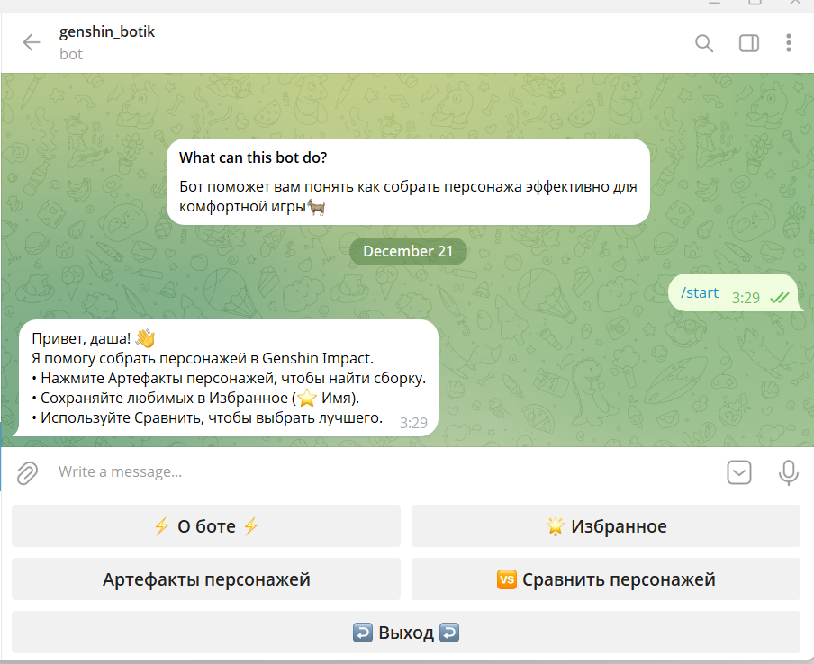

При нажатии на кнопку «Артефакты персонажей» бот попросит ввести имя персонажа игры:
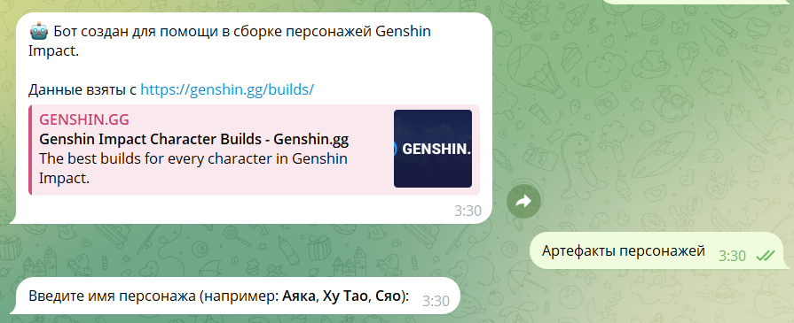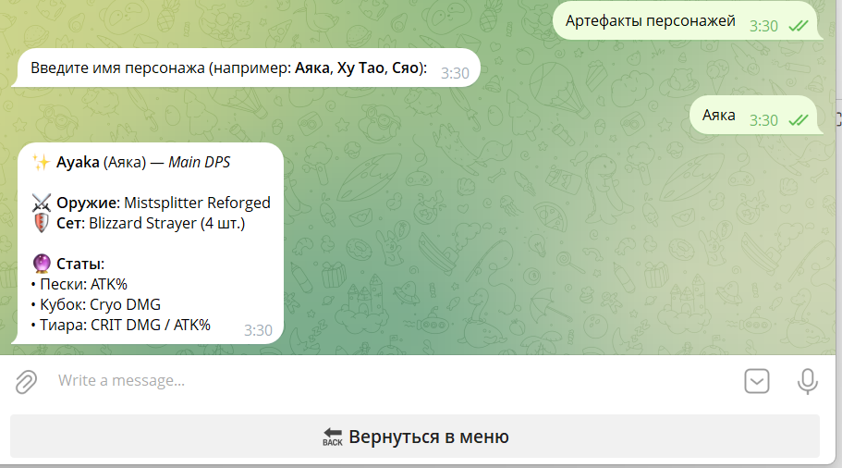
При нажатии на кнопку «Сравнить персонажей» мы должны будем вписать как первого, так и второго персонажа и сравнит их по характеристикам:
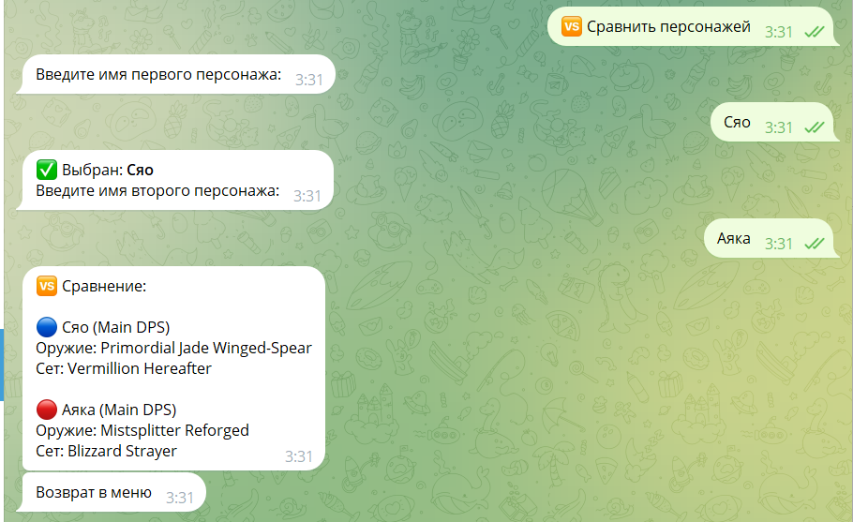

При нажатии на кнопку «Избранное» мы вписываем имя персонажа, и мы можем его для себя сохранить:

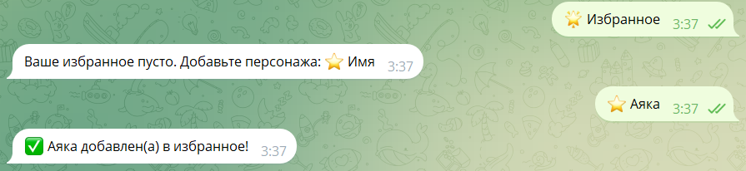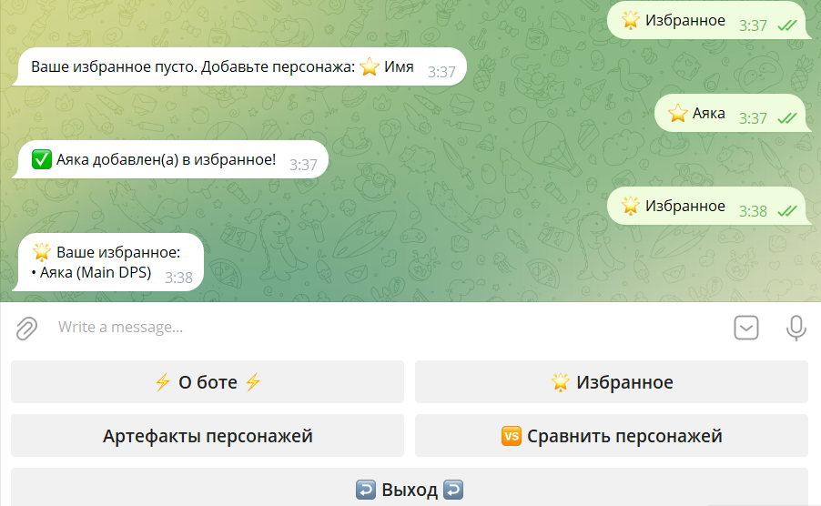

При нажатии на кнопку «Выход» бот прощается с нами и программа заканчивается:

